**Illustration: Agent Orchestration to process a query**

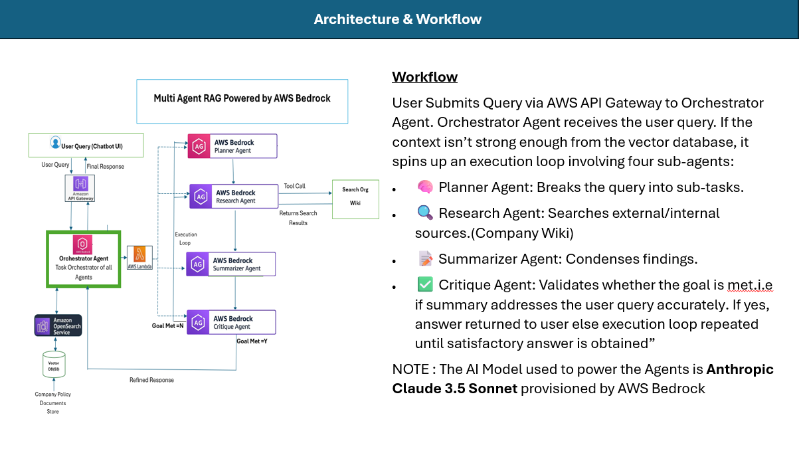

**Once a query is triggered , the query is passed down to the agentic network where it is processed in the following manner as logged in the CloudWatch Logs**

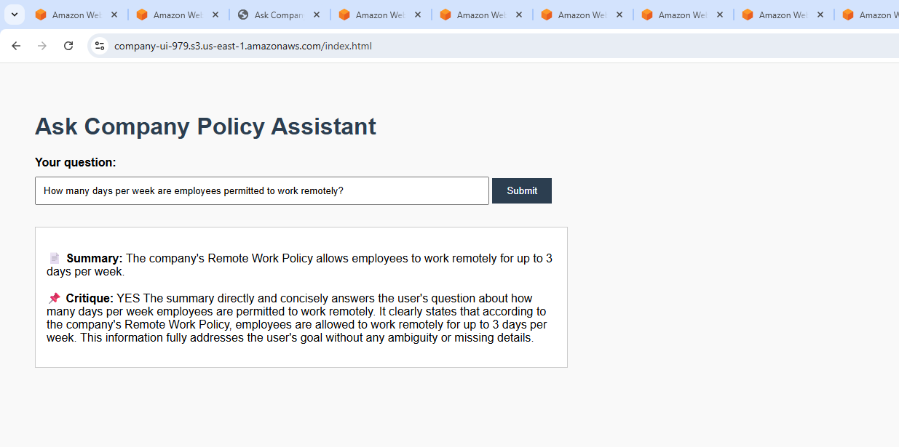

Agent Orchestration

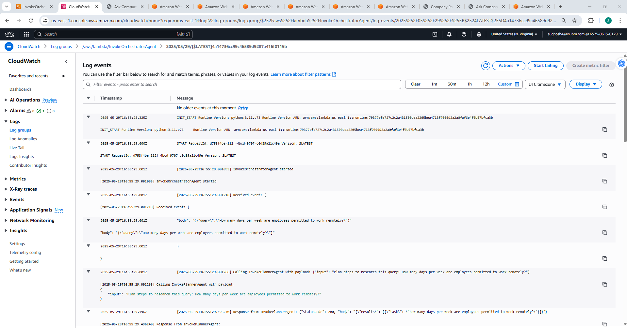

**2.Orchestrator instructs Planner Agent to Plan the steps**

**1.Orchestrator Receives Query**

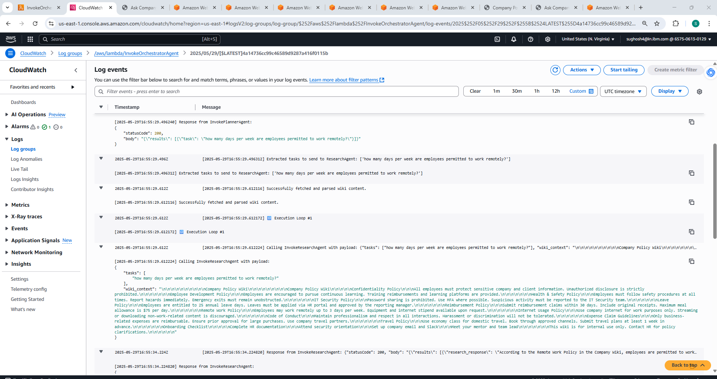

**4.Research Agent finds the info from Company wiki and returns wiki context**

**3.Planner Agent responds with planned tasks which are sent to Research Agent**

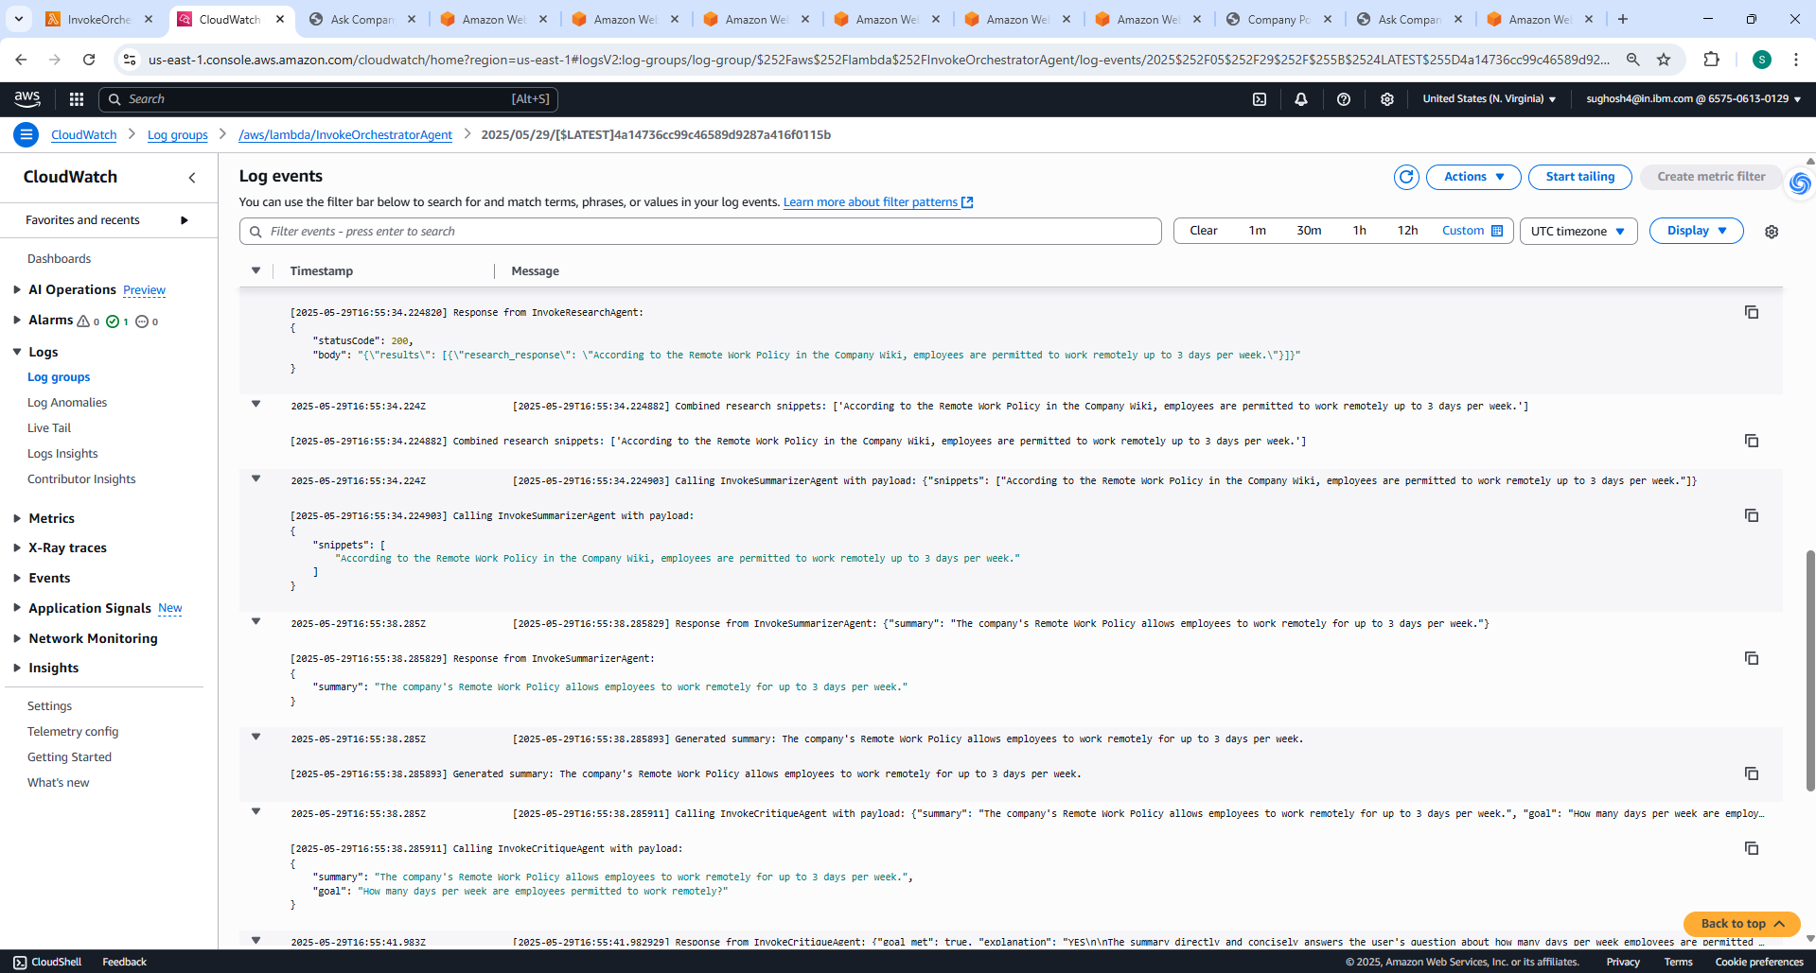

**6.Summarizer Agent summarizes from research snippets and passes onto Critique Agent along with goal**

**5.Research Agent finds and returns relevant research snippets which is sent to Summarizer Agent**

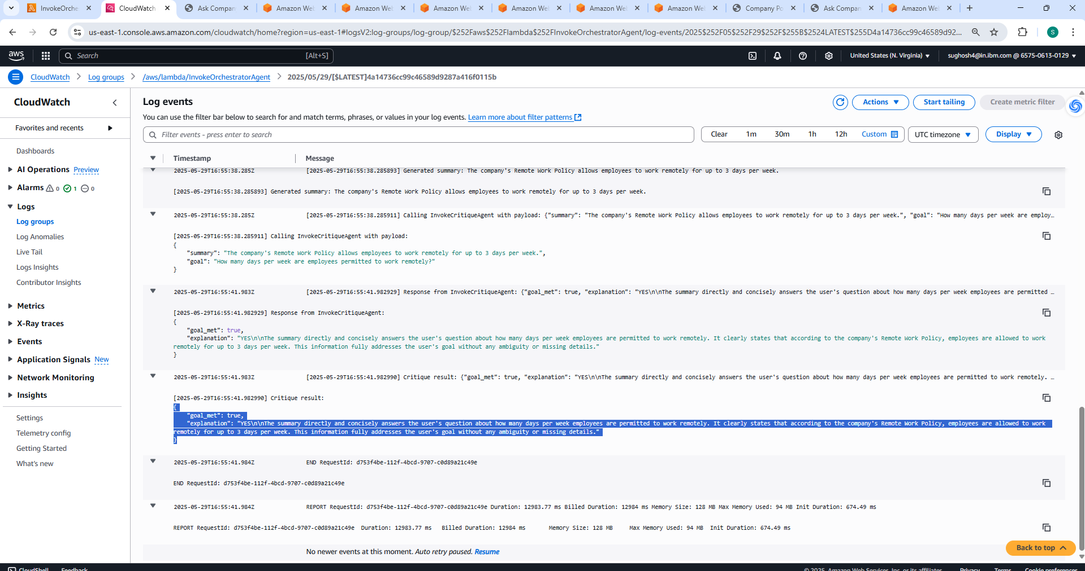

**7. Critique Agent evaluates if the Summary correctly addresses the user query and if yes , marks Goal Met as true with an explanation and answer is returned back to user via the Orchestrator. If Goal met=false , Critique agent will inform Orchestrator and orchestrator will ask the sub agents(Planner , researcher, summarizer , critique) to try again until a satisfactory answer is found.**